General Style:
What a better way to describe than using some things I like from other games and things I’ve seen
I want the background to be tile-able (repeatable), Sort of like Some of the following:
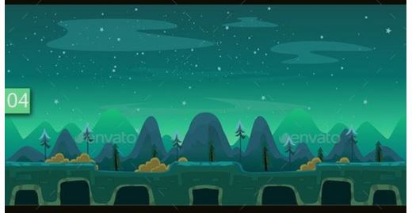
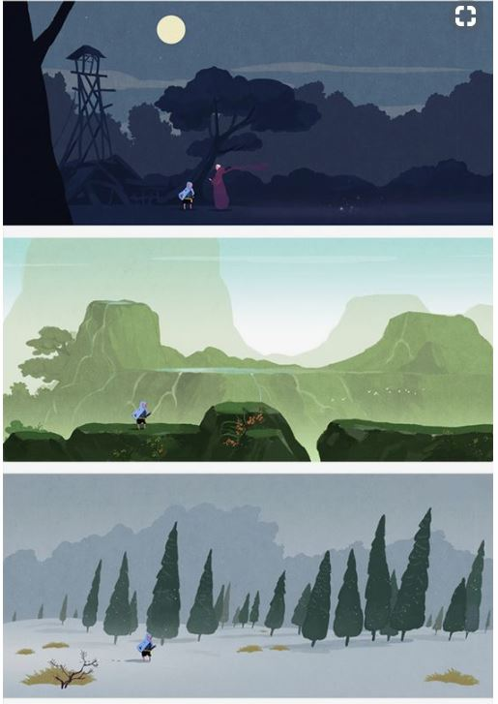
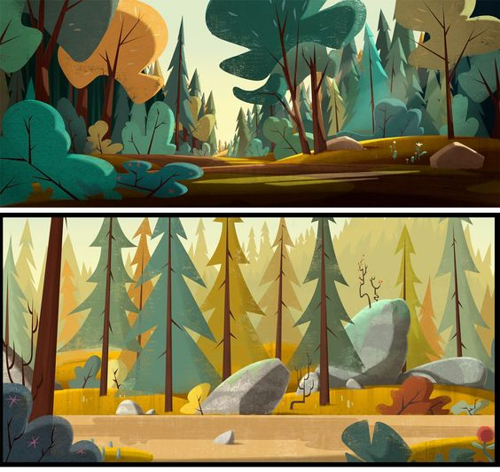
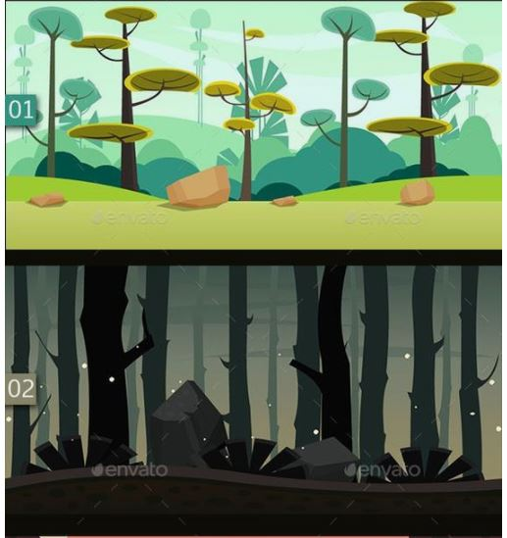
The textures in all of these are fantastic as well

Animation Style
Animated on Ones or Twos
Animate: Walk, Run, Crouch, Injured?, Throw, Cube return, Push, Jump, Pick up.
I really like the idea of having 2d animation.
The background and every other asset will be done in 3d
- Modeled in Maya
- Painted in Substance Painter
With painterly style textures, as seen in the general style ideas.

Audio
Depending on the area music from the film may fit well here.
There will be folly sounds for: stepping, jumping, grunting, growling, hurting, yelling, etc
VFX
Tiny bits of dust when stopping.
Weather?
Drool
Color Flash when enemies attack

Info For Playtesters:
Capsule = character
Large Capsule = Bear
Moving Speres = Enimies
Green Sphere = Fruit (Please be patient, there is an issue with fruit not disappearing like supposed to in build.)
Boxes pushable/button/switch

Questions:
Does the Game progress make sense?
Is it difficult enough to challenge you/ easy enough so everyone can play?
Does the companion cube work in the game? Is it used enough/not enough?
Did anything “break” during your play test?
What is Something You think could be better?

